CURRICULUM VITAE

RIFAT ULLAH

UAE = 052-6730060
afridirifat4@gmail.com
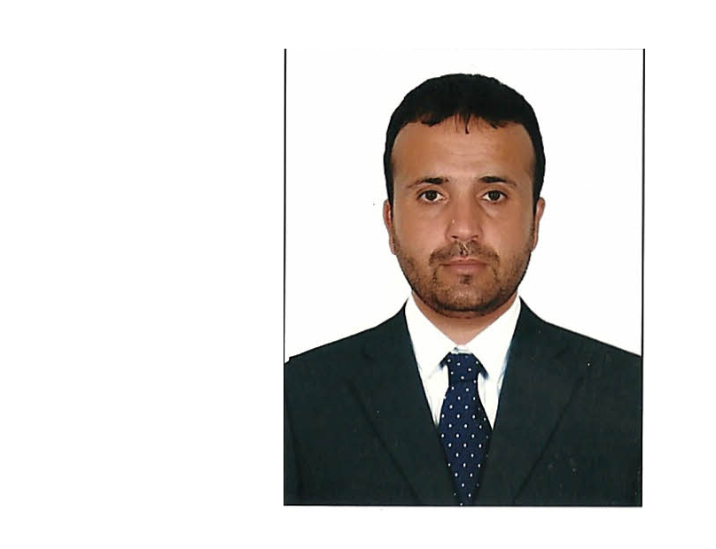

CAREER OBJECTIVES:
To be part of an organization that provides opportunity for personal growth and to contribute towards the development of such organization to the best of my abilities.

Store keepers and procurement/Material recording clerks keep track of information in order to keep businesses and supply chains on schedule. They ensure proper scheduling, record keeping, and inventory control keeping, and inventory control. In Purchasing send LPO as per need for store requirements.

Academic Qualification:

- FSc (Chemistry, Biology, Physics, English)
- BSc (Chemistry, Zoology, Geography)

Computer Skills: System Application Program (SAP), MS Words, Excel, Internet , PowerPoint, Out Look, Adempiere Software…

- Excellent knowledge of Operating System
- Basic Concepts of Information Technology using computer & managing Files.
- Internet Operating

ABU DHABI NATIONAL HOTELS COMPASS LLC

AS A STORE KEEPER + PURCHASING

IN THE PROJECT (SH. ZAYED MILITARY HOSPITAL ABU DHABI)

Position held: Store keeper Period: 2012 to January 2015
(From same project Sh. Zayed M Hospital Abu Dhabi also check control on
ICLDC, Al Nahyan, Al Dhafra Hospital, Cancer center.

MAIN RESPONCIBLITIES & DUTIES

• Prepared and approved purchase orders (LPO) before ordering goods.
• Processed purchasing requests and maintained purchasing logs.
• Contacted vendors to obtain price quotes and performed negotiations.
• Ensured that all purchase operations were performed in accordance with company policies.
• Followed-up on delivery schedules, payment delays and invoice queries.
• Managed delivery schedules and status of goods.
• Maintained records of purchases and sales.
• Coordinate with suppliers to ensure that goods are delivered on time.
• Negotiated price and terms with suppliers.
• Inspected goods for any defects and missing materials.
• Recommended improvements to purchasing procedures for operational efficiency.
• Performed purchase operations within the assigned budget.
• Execution and monitoring of all regular purchasing duties.
• Support relevant departments with quotations for the purpose of tenders.
• Maintain complete updated purchasing records and pricing in the system.

SAFETY COURSE + SAP TRAINING

Basic Safety Course: (Abu Dhabi National Hotels )
System Application Program ( SAP )Training : ( Abu Dhabi National Hotels )

AS A SERVICE COORDINATOR IN PRECISION INDUSTRIES LLC DUBAI (POWER GENERATOR COMPANY)

Position held : service coordinator period : for one years

MAIN RESPONCIBLITIES & DUTIES

• Follow all relevant operational procedures and instructions that work is carried out in a controlled and consistent manner.
• Managing the warehouse area and check materials transfer forms and emails from branches regarding materials and finished items and direct the related personnel.
• A close and strict watch and activities of the warehouse staff such as a store keeper, helpers etc. to avoid any malpractices and misappropriation of the goods by any means possible through them.
Note : Take a training of Adempiere Soft ware ……

DOCUMENT CONTROLLER IN REHMAN MEDICAL INSTITUTE PAKISTAN :

Position held: Sales + Document controller Period: 19-01-2011 to 31-08-2012
Responsible for requisitioning, receiving, inspecting, storing and controlling medicines and Finished Products stock in computers system and issuing as per request and sales order.
• Proper and accurate utilization of stores as per computer system.

UAE LIGHT VEHICLE DRIVING LICENSE

Issue Date : 14-09-2014

Expiry Date : 13-09-2024

Personal Detail

Name : Rifat Ullah
Date of Birth : 14/10/1983
Nationality : Pakistani
Sex : Male
Marital status : Married
Language Known : English, Urdu, Arabic
Visa status : Visit visa (from 21 Oct 2016 to 19 January 2017)
Email Address : afridirifat4@gmail.com

Passport Details

Passport No : AB9570712
Date of Issue : 15 Aug 2012

Date of Expiry : 14 Aug 2017

DECLARATION

I hereby declare that all the information given above is true and correct to the best of my knowledge and belief.

Note : Now I am on visit visa

